John Maher

Chapter 8

Pg 285

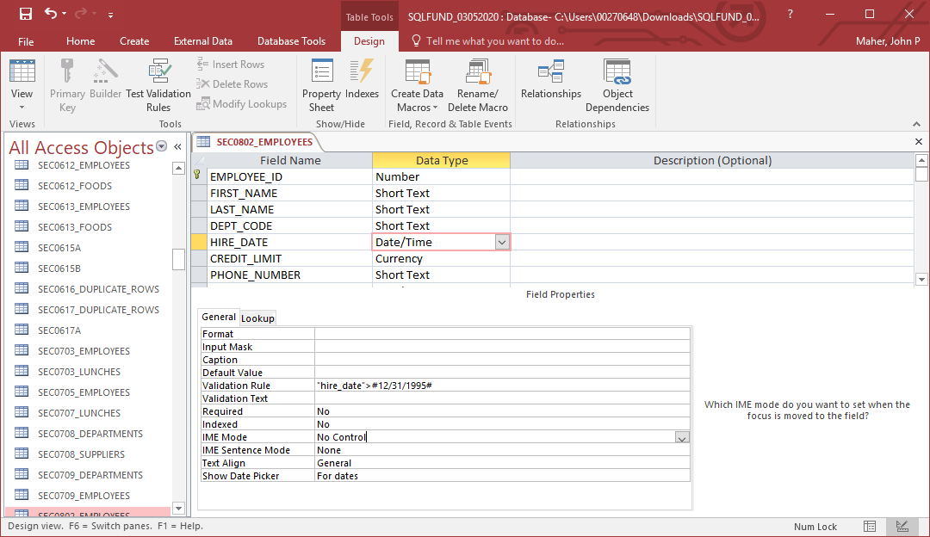

Pg 286

ALTER TABLE sec0803_employees ADD CONSTRAINT unique_sec0803b_emp_phone_num unique (phone_number);

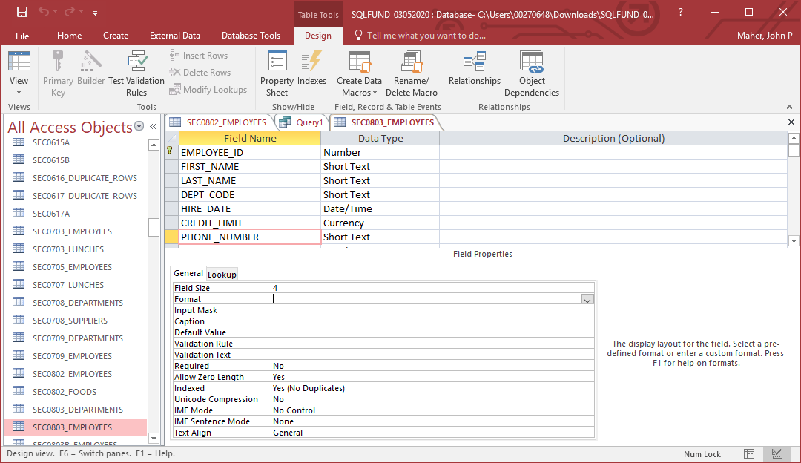

Pg 287

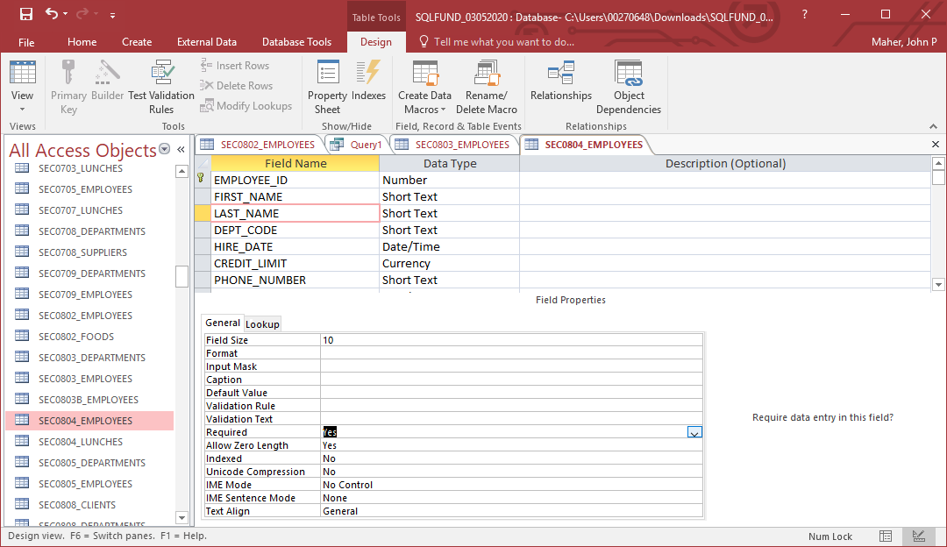

Pg 289

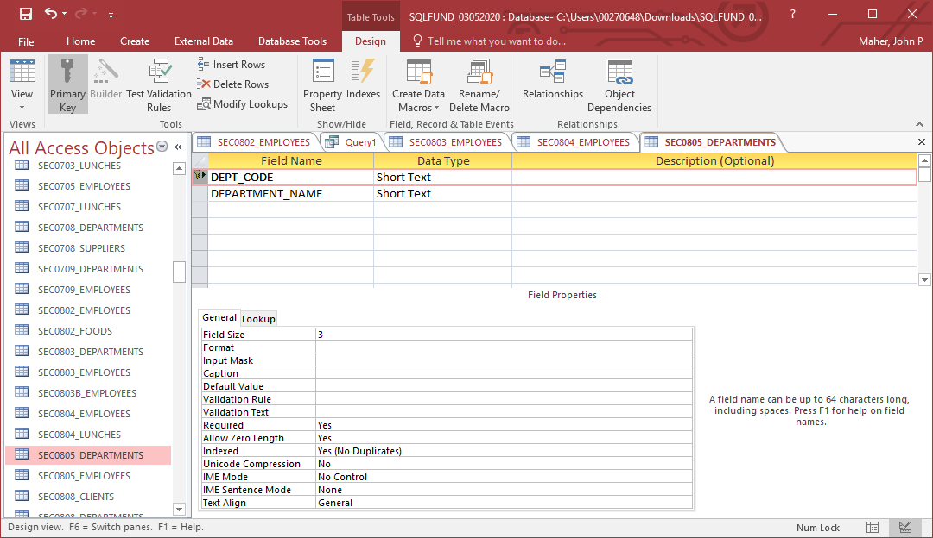

Pg 292

ALTER TABLE sec0808_employees ADD CONSTRAINT fk_sec0808_dept_code FOREIGN KEY (dept_code) REFERENCES sec0808_departments (dept_code);

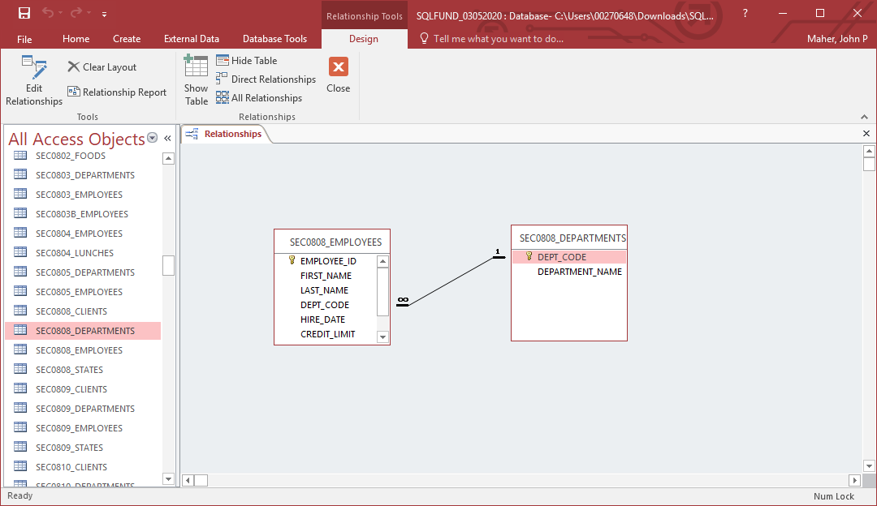

Pg 299

| **SEC0813_DEPARTMENTS** | |
| --- | --- |
| **DEPT_CODE** | **DEPARTMENT_NAME** |
| Act | Accounting |
| Exe | Executive |
| Mkt | Marketing |
| Per | Personnel |
| Sal | Sales |
| Shp | Shipping |

| **SEC0813_EMPLOYEES** | | | | | | | |
| --- | --- | --- | --- | --- | --- | --- | --- |
| **EMPLOYEE_ID** | **FIRST_NAME** | **LAST_NAME** | **DEPT_CODE** | **HIRE_DATE** | **CREDIT_LIMIT** | **PHONE_NUMBER** | **MANAGER_ID** |
| 201 | Susan | Brown | Exe | 6/1/1998 | $30.00 | 3484 |  |
| 202 | Jim | Kern | Sal | 8/16/1999 | $25.00 | 8722 | 201 |
| 203 | Martha | Woods | Shp | 2/2/2009 | $25.00 | 7591 | 201 |
| 204 | Ellen | Owens | Sal | 7/1/2008 | $15.00 | 6830 | 202 |
| 205 | Henry | Perkins | Sal | 3/1/2006 | $25.00 | 5286 | 202 |
| 206 | Carol | Rose | Act |  |  |  |  |
| 207 | Dan | Smith | Shp | 12/1/2008 | $25.00 | 2259 | 203 |
| 208 | Fred | Campbell | Shp | 4/1/2008 | $25.00 | 1752 | 203 |
| 209 | Paula | Jacobs | Mkt | 3/17/1999 | $15.00 | 3357 | 201 |
| 210 | Nancy | Hoffman | Sal | 2/16/2007 | $25.00 | 2974 | 203 |

INSERT INTO sec0813_departments VALUES ('ABC', 'Shipping’);

UPDATE sec0813_employees SET dept_code = 'ABC' WHERE dept_code = 'Shp';

DELETE FROM sec0813_departments WHERE dept_code = 'Shp';

| **SEC0813_DEPARTMENTS** | |
| --- | --- |
| **DEPT_CODE** | **DEPARTMENT_NAME** |
| ABC | Shipping |
| Act | Accounting |
| Exe | Executive |
| Mkt | Marketing |
| Per | Personnel |
| Sal | Sales |

| **SEC0813_EMPLOYEES** | | | | | | | |
| --- | --- | --- | --- | --- | --- | --- | --- |
| **EMPLOYEE_ID** | **FIRST_NAME** | **LAST_NAME** | **DEPT_CODE** | **HIRE_DATE** | **CREDIT_LIMIT** | **PHONE_NUMBER** | **MANAGER_ID** |
| 201 | Susan | Brown | Exe | 6/1/1998 | $30.00 | 3484 |  |
| 202 | Jim | Kern | Sal | 8/16/1999 | $25.00 | 8722 | 201 |
| 203 | Martha | Woods | ABC | 2/2/2009 | $25.00 | 7591 | 201 |
| 204 | Ellen | Owens | Sal | 7/1/2008 | $15.00 | 6830 | 202 |
| 205 | Henry | Perkins | Sal | 3/1/2006 | $25.00 | 5286 | 202 |
| 206 | Carol | Rose | Act |  |  |  |  |
| 207 | Dan | Smith | ABC | 12/1/2008 | $25.00 | 2259 | 203 |
| 208 | Fred | Campbell | ABC | 4/1/2008 | $25.00 | 1752 | 203 |
| 209 | Paula | Jacobs | Mkt | 3/17/1999 | $15.00 | 3357 | 201 |
| 210 | Nancy | Hoffman | Sal | 2/16/2007 | $25.00 | 2974 | 203 |